Test Case: tc001_SPX_Dev5_Crear_Solicitud_Articulo_Almacen
Step 1 - Enter username and password and click to button Enter : Credentials Entered
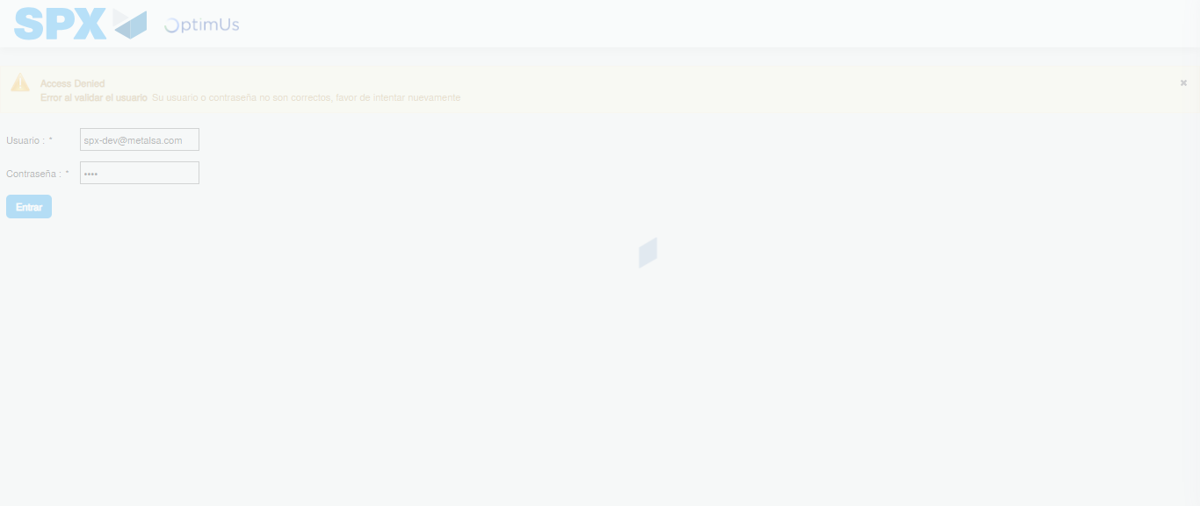Image file-name: QC_Testing-tc001_SPX_Dev5_Crear_Solicitud_Articulo_Almacen-1787940413932

Step 2 - Select to UEN and Access to Request for a New Inventory Item : UEN Correctly selected and Correct access
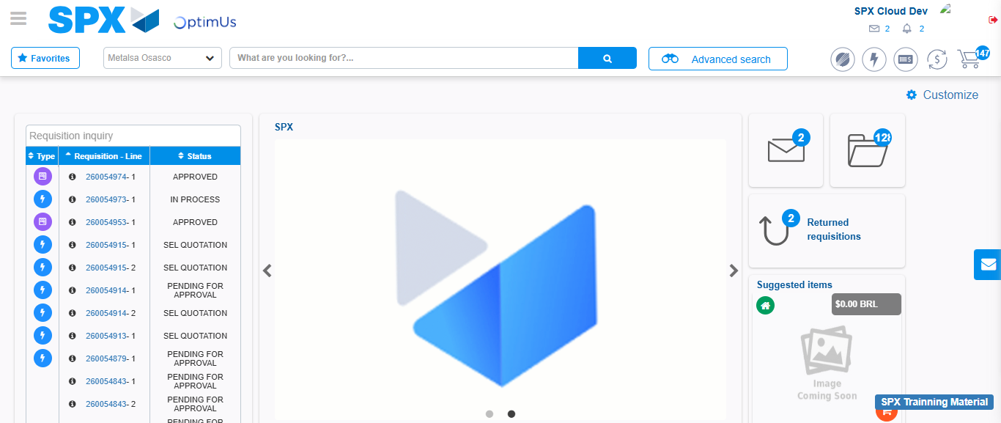Image file-name: QC_Testing-tc001_SPX_Dev5_Crear_Solicitud_Articulo_Almacen-1787940441282

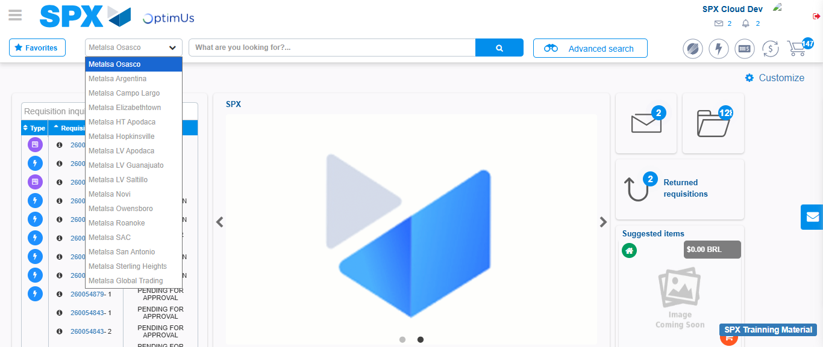Image file-name: QC_Testing-tc001_SPX_Dev5_Crear_Solicitud_Articulo_Almacen-1787940441951

Image file-name: QC_Testing-tc001_SPX_Dev5_Crear_Solicitud_Articulo_Almacen-1787940450914

Step 3 - Select options first section : Options seleted correctly
Image file-name: QC_Testing-tc001_SPX_Dev5_Crear_Solicitud_Articulo_Almacen-1787940451227

Image file-name: QC_Testing-tc001_SPX_Dev5_Crear_Solicitud_Articulo_Almacen-1787940451434

Step 4 - Select options at Screen: Options seleted correctly
Image file-name: QC_Testing-tc001_SPX_Dev5_Crear_Solicitud_Articulo_Almacen-1787940451227

Image file-name: QC_Testing-tc001_SPX_Dev5_Crear_Solicitud_Articulo_Almacen-1787940451434

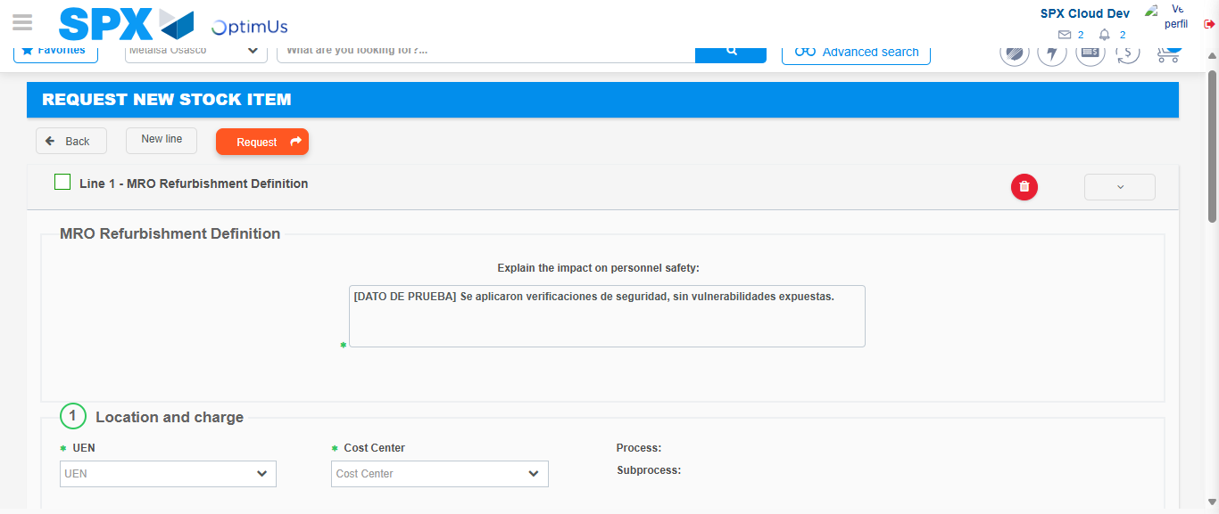Image file-name: QC_Testing-tc001_SPX_Dev5_Crear_Solicitud_Articulo_Almacen-1787940458002

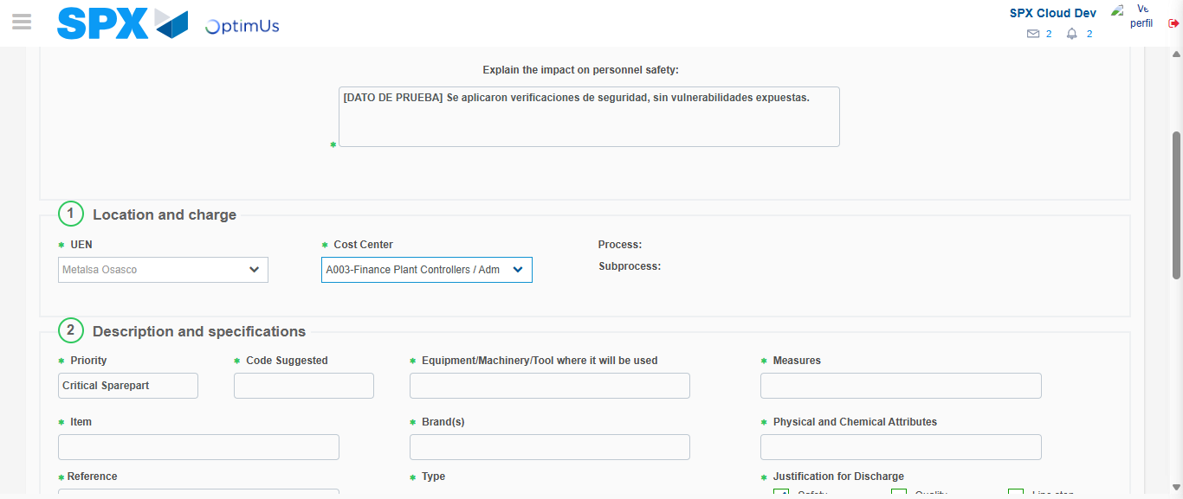Image file-name: QC_Testing-tc001_SPX_Dev5_Crear_Solicitud_Articulo_Almacen-1787940460833

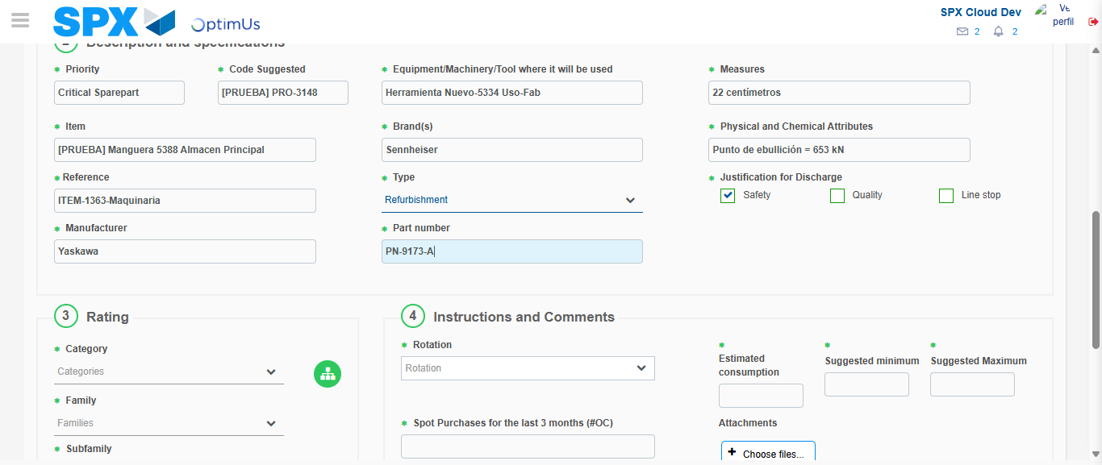Image file-name: QC_Testing-tc001_SPX_Dev5_Crear_Solicitud_Articulo_Almacen-1787940462783

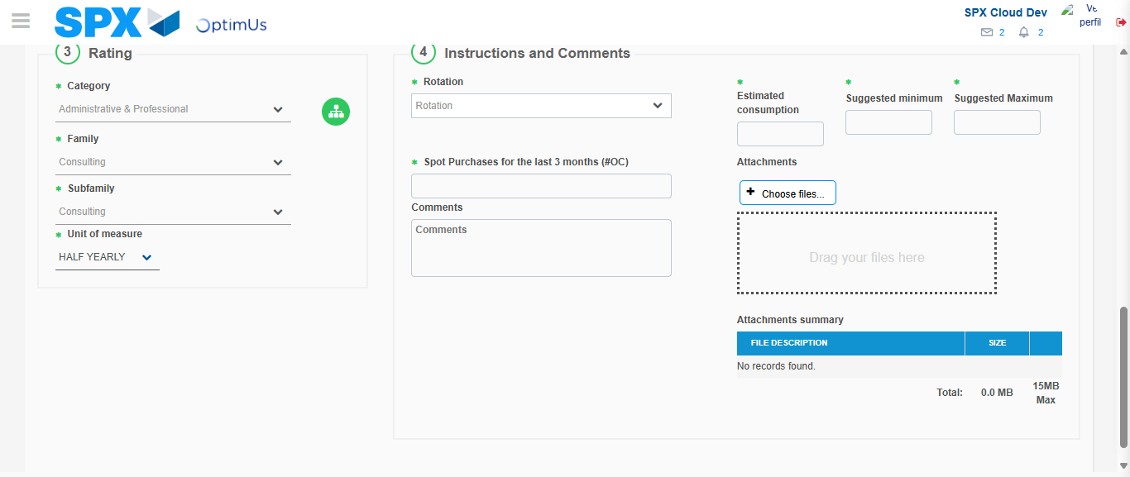Image file-name: QC_Testing-tc001_SPX_Dev5_Crear_Solicitud_Articulo_Almacen-1787940467762

Step 5 - Request New Item : Request Accepted
Image file-name: QC_Testing-tc001_SPX_Dev5_Crear_Solicitud_Articulo_Almacen-1787940441282

Image file-name: QC_Testing-tc001_SPX_Dev5_Crear_Solicitud_Articulo_Almacen-1787940441951

Image file-name: QC_Testing-tc001_SPX_Dev5_Crear_Solicitud_Articulo_Almacen-1787940450914

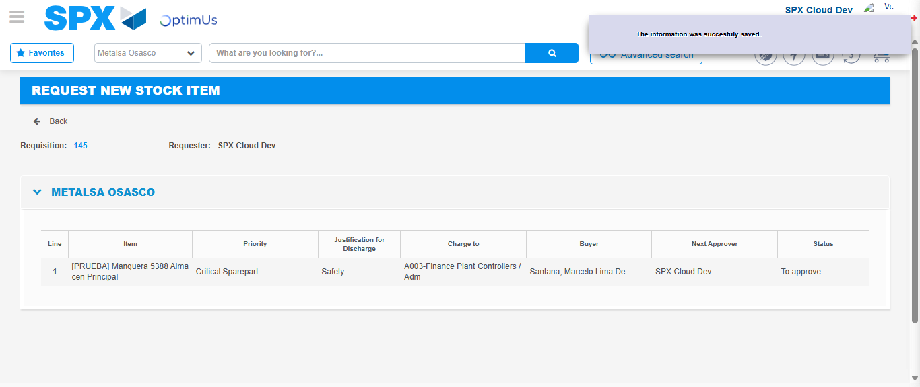Image file-name: QC_Testing-tc001_SPX_Dev5_Crear_Solicitud_Articulo_Almacen-1787940474619

Image file-name: QC_Testing-tc001_SPX_Dev5_Crear_Solicitud_Articulo_Almacen-1787940474835

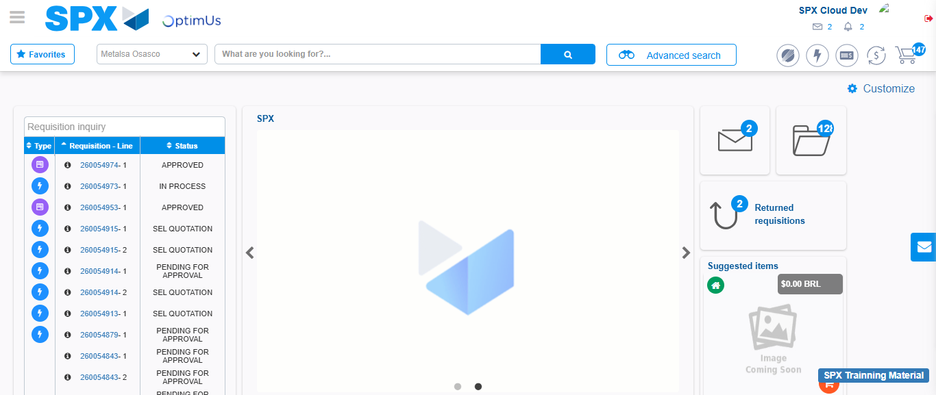Image file-name: QC_Testing-tc001_SPX_Dev5_Crear_Solicitud_Articulo_Almacen-1787940496322

Step 7 - Return to Main Page SPX : Return to Main Page SPX
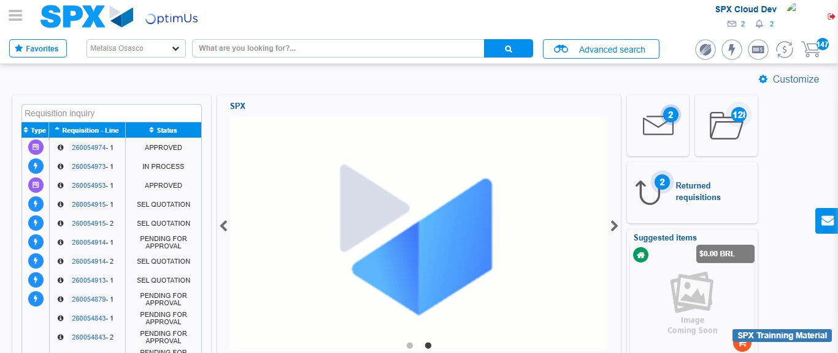Image file-name: QC_Testing-tc001_SPX_Dev5_Crear_Solicitud_Articulo_Almacen-1787940496664

